The main duty of a Circuit Breaker is to switch ON and OFF the electrical circuits during normal or abnormal operating conditions, once or several times repeatedly.

**Theory of operation:**

A typical circuit breaker consists of a fixed and a moving contact called Electrodes. These contacts are closed under normal conditions.

If a fault occurs in the system, the contacts will open automatically and they can be opened manually.

During fault conditions, a simple mechanism will pull the moving contacts away as a result of trip coil getting energized and essentially opening the circuit.

#### Types of circuit breakers:

[Circuit breakers](https://cselectric.co.in/products-solutions/low-voltage-switchgear/circuit-breakers/) mainly are categorized on the basis of application as per voltage:

**Low Voltage Circuit Breaker**

* MCCB
* ACB
* MCB
* RCCB

**Medium Voltage Circuit Breakers**

* SF6/VACUUM Circuit Breakers

**High Voltage Circuit Breakers**

* VCB
* SF6
* OCB
* ABCB

#### ****LOW VOLTAGE CIRCUIT BREAKERS****

Circuit Breakers operating for the voltage up to 1KV are LV or Low Voltage Circuit Breakers which are as follows:

* **MOLDED CASE CIRCUIT BREAKER**

MCCB or [Molded Case Circuit Breaker](https://cselectric.co.in/products-solutions/low-voltage-switchgear/circuit-breakers/moulded-case-circuit-breakers/) is a kind of circuit breaker which is enclosed in the moulding or housing of a moulded material & that is the reason it is known as Molded Case Circuit Breaker. It is generally used for the current ratings up to 1600A & fault level up to 150KA. It offers protection against overload & short circuits through bimetal & solenoid, these days Microprocessor based MCCBs are being very popular due to the quick functioning of their electronic type release.

**Applications:**

These breakers are most commonly applied when very high fault levels are available and with applications where the current limiting capability is used upstream of the final load to limit current to the load. Typical loads include lighting and power distribution, and motor controller applications.

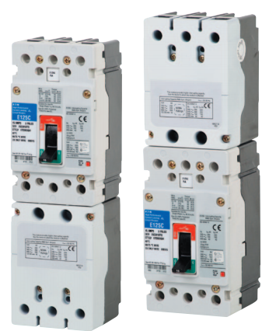

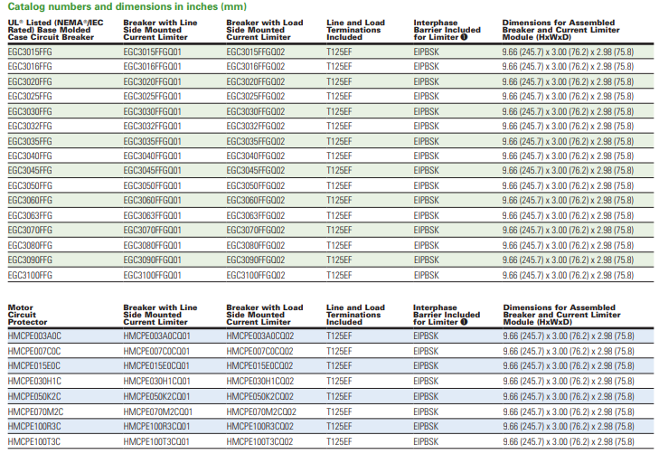

* **MINIATURE CIRCUIT BREAKER**

MCB or Miniature Circuit Breaker is a circuit breaker which is used for protection where current ratings are lower. It can be used upto 125A circuits & like MCCBs it also offers protection against overload & short circuit through bimetal & solenoid. These days Class 3 MCBs are very popular due to their ability of tripping quickly & also minimum loss of let through energy.

* **AIR CIRCUIT BREAKER**

AIR CIRCUIT BREAKER or ACB as the name suggests it’s the circuit breaker where the medium of arc quenching is air. ACB is used for the high current applications, or we can say that ACB can offer protection against overload & short circuit upto 6300A. Tripping in ACB is achieved through release. The release is known as the mind of ACB as it only suggests the ACB to trip in case of fault.

* **MOTOR PROTECTION CIRCUIT BREAKER (MPCB):**

MPCBs are used specially for motor protections. [MPCB](https://cselectric.co.in/products-solutions/low-voltage-switchgear/circuit-breakers/motor-protection-circuit-breakers/) as a standalone device offers protection against Overload, Short Circuit & Single Phasing, thus is used specifically for motor applications.

* **RESIDUAL CURRENT CIRCUIT BREAKER (RCCB):**

RCCBs as the name suggests offer protection against Earth Leakage. It is used in homes, offices & industries according to the current sensitivity required as per application. In case of current leakage it senses the same & trips thus, saving the human & circuit from shock & adverse effects of current leakage.

#### MEDIUM VOLTAGE & HIGH VOLTAGE CIRCUIT BREAKERS

Voltage level from 1KV-69KV is categorized under medium & 69KV-230KV is categorized as High Voltage. Circuit Breakers operating in these voltage ranges are known as Medium & High Voltage CBs respectively.

* **VACUUM CIRCUIT BREAKER**

Vacuum Circuit Breaker or VCB is used for Medium Voltage applications. In VCB the contacts operation & arc quenching takes place inside bottles where Vacuum is present.

[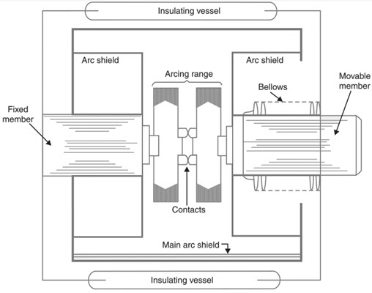](https://www.electronicshub.org/wp-content/uploads/2019/05/Different-Types-of-Circuit-Breakers-Vacuum-Circuit-Breakers-VCB.jpg)

**Advantages:**

* No fire hazards.
* Compact, very reliable and have very long life.
* No gas is generated during or after operation.
* No or very little maintenance.
* VCB can interrupt any fault current.
* Can withstand lightning strikes.
* Low arc energy is released.
* **SF6 CIRCUIT BREAKER**

SF6 circuit breakers are also used mainly in medium voltage applications. In this breaker SF6 gas is used for arc quenching due to its ability of quenching the arc very efficiently. SF6 Breakers being highly efficient in arc quenching are still not preferred much as SF6 being a poisonous gas, is dangerous to environment & humans.

[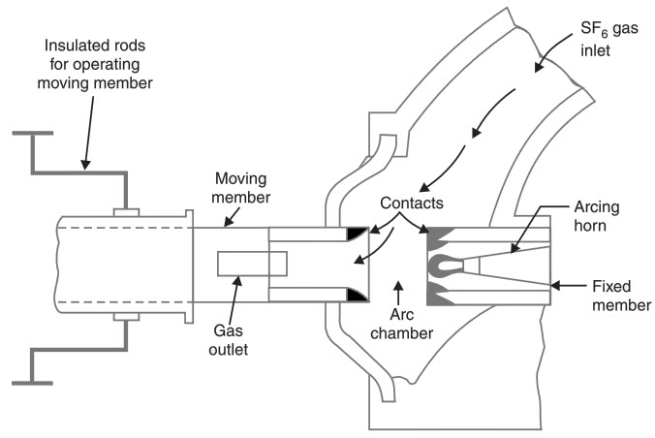](https://www.electronicshub.org/wp-content/uploads/2019/05/Different-Types-of-Circuit-Breakers-Sulphur-Hexafluoride-Circuit-Breakers.jpg)

**Advantages:**

* Superior arc extinguishing property.
* Can interrupt larger currents as the dielectric strength of SF6 gas is almost 3 times greater than air.
* Noise free operation and no exhaust into atmosphere.
* Moisture free operation as the gas filled chamber keeps in interior dry.
* Very low maintenance and requires minimum equipment.
* Suitable for hazardous and hostile conditions like coal mines as the breakers are enclosed and sealed.

**Disadvantages**

* Sulfurhexafluoride gas is very costly.
* SF6 has to be reconditioned after every operation.
* This high pressure Sulfurhexafluoride gas will absorb all the conducting free electrons and as a result causes the extinction of the arc.
* **OIL CIRCUIT BREAKER**

Oil Circuit Breakers were also used on high voltages & Oil was used as the arc quenching medium.

**Advantages**

* Oil has excellent cooling property and the arc energy converts the oil into gas.
* Acts as insulator between live wires and earth.

**Disadvantages**

* Oil is inflammable and is a fire hazard.
* Arcing products cannot escape and remain in the oil.

[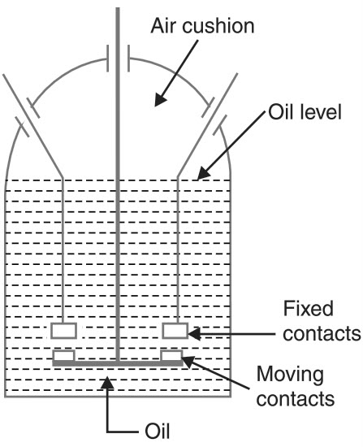](https://www.electronicshub.org/wp-content/uploads/2019/05/Different-Types-of-Circuit-Breakers-Plain-Break.jpg)

**Applications of Circuit Breakers:**

* They are used for switching of loads in Industries, Buildings, Commercial complexes, Hotels etc.
* Air C/B is used for the protection of plants, electrical machines, transformers, capacitors and generators.
* Air Blast C/B is used in Indian Railways for electrification.
* Thermal and Magnetic Protection

**Criteria in choosing the circuit breaker:**

* Electrical characteristics (AC or DC, Voltage...) of the installation for which the CB is intended
* Its environment: ambient temperature, in a kiosk or switchboard enclosure, climatic conditions, etc.
* Presumed short-circuit current at the point of installation
* Characteristics of the protected cables, busbars, busbar trunking system and application (distribution, motor...)
* Co-ordination with upstream and/or downstream device: selectivity, cascading, coordination with switch disconnector, contactor...
* Operational specifications: requirements (or not) for remote control and indication and related auxiliary contacts, auxiliary tripping coils, connection
* Installation regulations; in particular: protection against electric shock and thermal effect (See [Protection against electric shocks and electrical fires](https://www.electrical-installation.org/enwiki/Protection_against_electric_shocks_and_electric_fires))
* Load characteristics, such as motors, fluorescent lighting, LED ligthing, LV/LV transformers

**Calculating a safe circuit load:**

, you first must add up the current of all the devices on the circuit that are on continuously, you just divide this number by the voltage at which it operates, which is either 120 volts or 240 volts.

Then, multiply this number by 125 percent.The rating of your circuit breaker must be larger than this total.

, you want your circuit to be operating at 80 percent of capacity, which is called the safe load. You can calculate a safe load for a circuit breaker by multiplying its amperage by 0.8. A circuit can operate at a higher percentage, but not for long periods of time as this can compromise safety.

**Selection Table:**

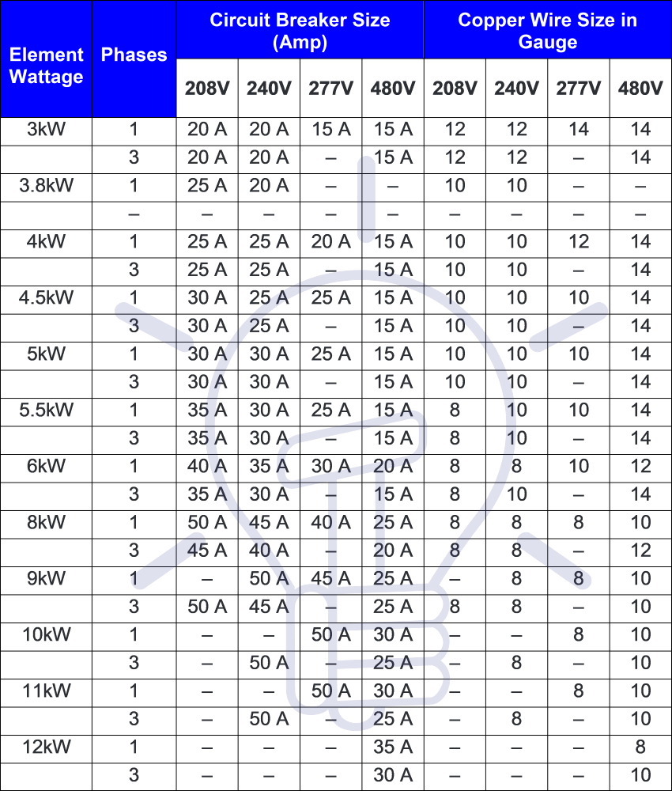

**Circuit breakers manufacturers:**

* [General Electric – GE](http://www.circuitbreaker.com/general-electric-ge-circuit-breakers/)
* [Westinghouse](http://www.circuitbreaker.com/westinghouse-circuit-breakers/)
* [Cutler-Hammer](http://www.circuitbreaker.com/cutler-hammer-circuit-breakers/)
* [Siemens – Allis Chalmers](http://www.circuitbreaker.com/siemens-allis-chalmers-circuit-breakers/)
* [ABB – BBC – Gould – ITE](http://www.circuitbreaker.com/abb-bbc-gould-ite-circuit-breakers/)
* [Federal Pacific](http://www.circuitbreaker.com/federal-pacific-circuit-breakers/)
* [Square D](http://www.circuitbreaker.com/square-d-circuit-breakers/)
* [PACS Industries](https://www.circuitbreaker.com/pacs-industries-circuit-breakers-switchgear/)

The Consumer Product Safety Commission (CPSC) estimates the life expectancy of a circuit breaker to be around 30 to 40 years, and it's the same for the GFCI, AFCI, and standard breakers. Because a breaker is a mechanical device, humid conditions or corrosive atmospheres will shorten the life span.

**References:**

<https://www.electronicshub.org/>

[current-limiting-circuit-breaker-pa01213001e.pdf (eaton.com)](https://www.eaton.com/content/dam/eaton/products/electrical-circuit-protection/molded-case-circuit-breakers/current-limiting-circuit-breaker-pa01213001e.pdf)

[Circuit Breaker - How it Works, Types, Applications and Advantages (electricalfundablog.com)](https://electricalfundablog.com/circuit-breaker-works-types-applications/#4_Applications_of_Circuit_Breaker)

[Selection of a circuit-breaker - Electrical Installation Guide (electrical-installation.org)](https://www.electrical-installation.org/enwiki/Selection_of_a_circuit-breaker)

[How to Size a Circuit Breaker | Hunker](https://www.hunker.com/12291117/how-to-size-a-circuit-breaker)

[How to Find the Proper Size of Circuit Breaker? CB Calculator (electricaltechnology.org)](https://www.electricaltechnology.org/2020/02/calculate-circuit-breaker-size.html)

[Understanding Your Breaker Box | White's Electrical](https://www.whiteselectrical.com/blog-post/understanding-breaker-box/)